Company Name: DI FELICE’S HVAC CORP.
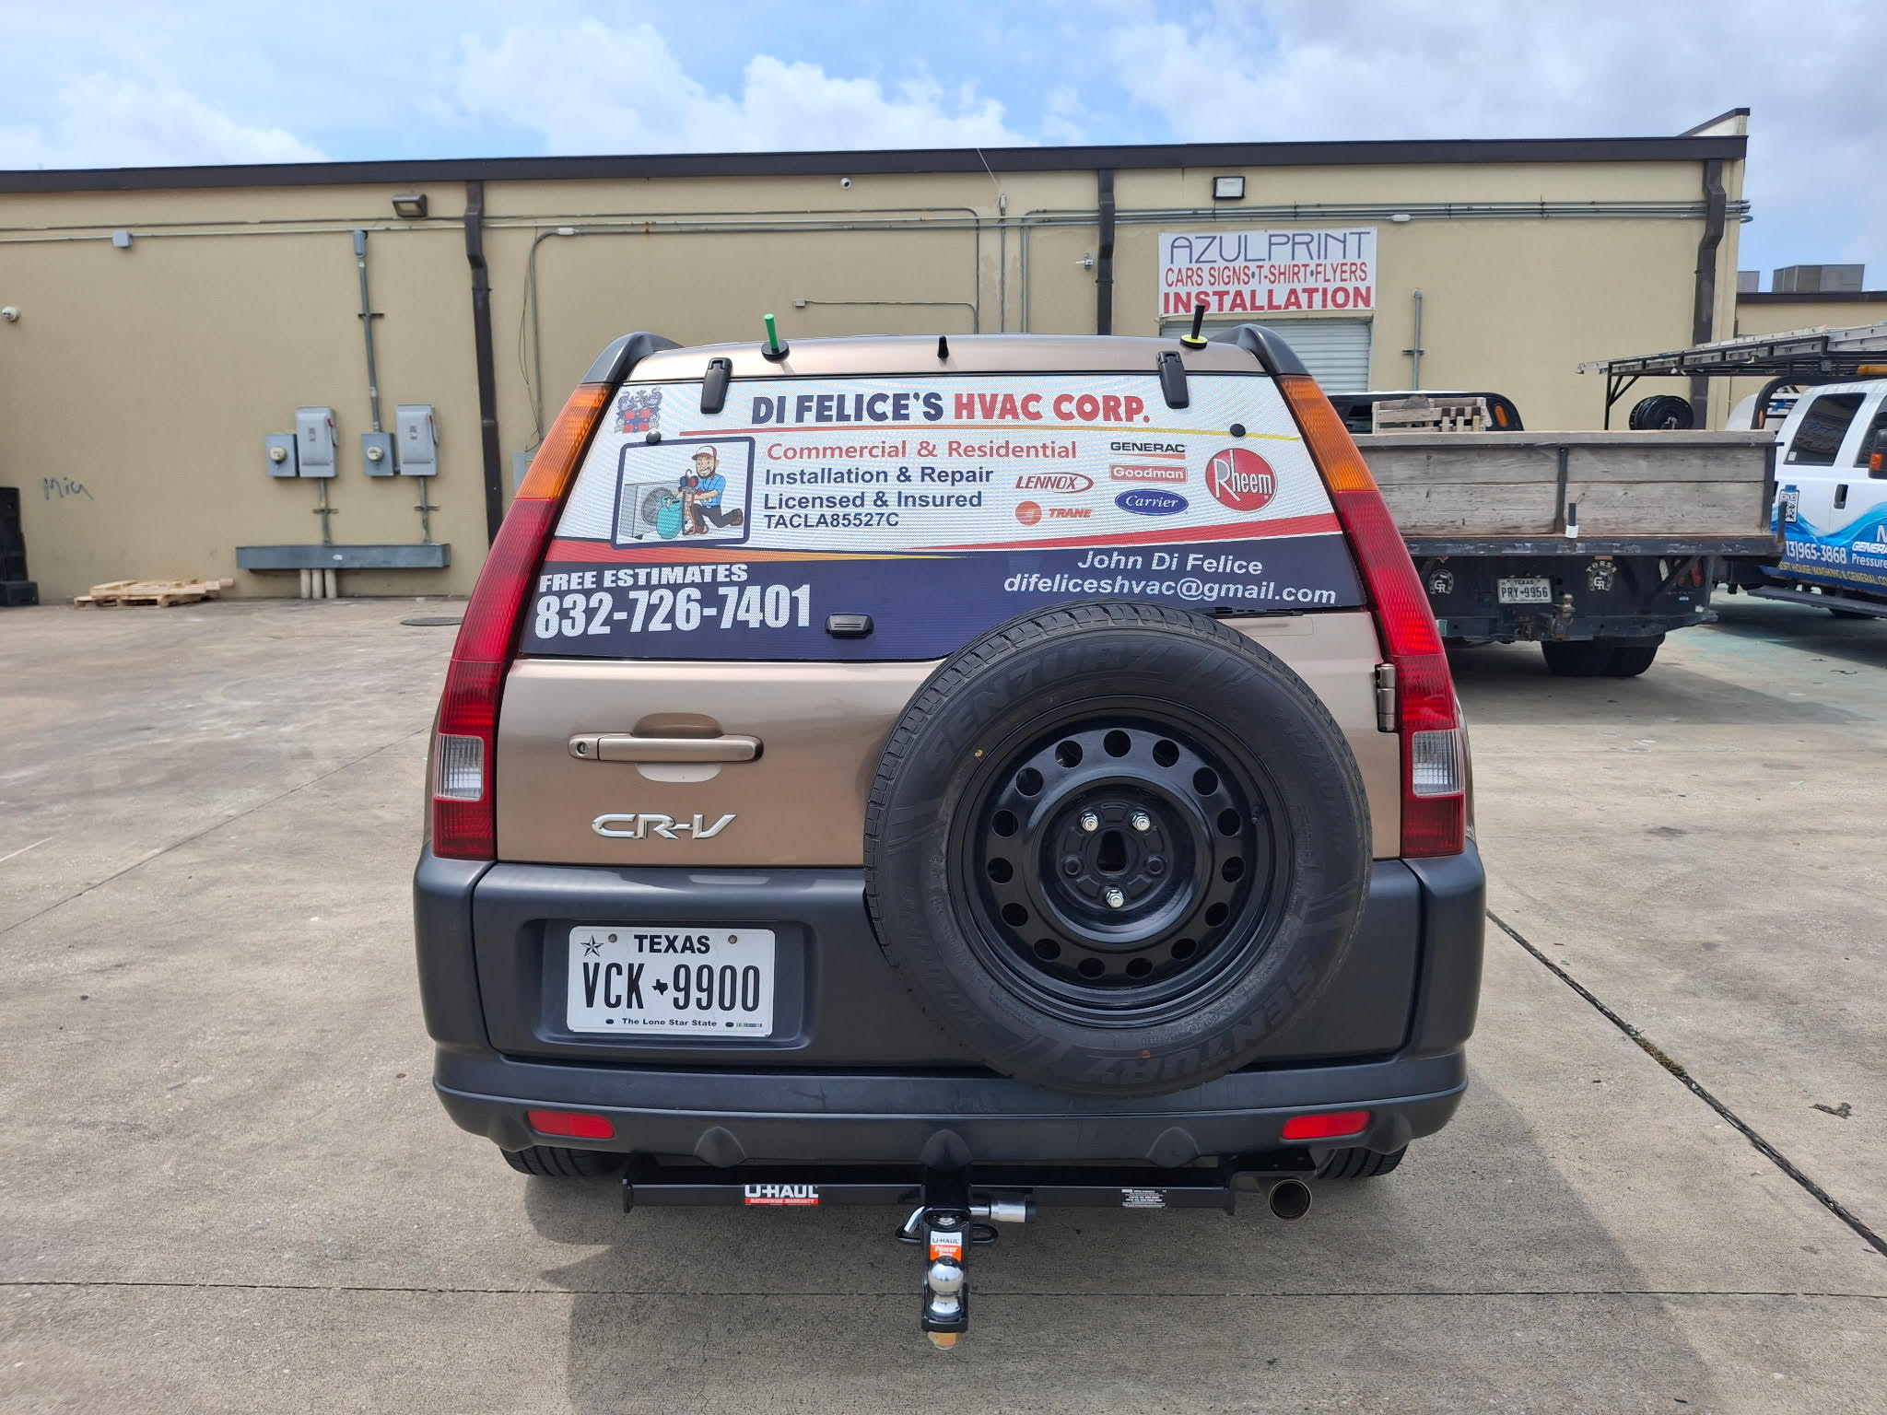

Hours of operation:
Mon-fri 8am-5pm
Sat 9am-noon

Review and understand all information in “C:\Users\jaynyasg\OneDrive\Documents\GitLab\AC\ac”

The site background image should be “C:\Users\jaynyasg\OneDrive\Documents\GitLab\AC\ac\background.png”. the site should be themed and colored around the background image respectively.

Reference “C:\Users\jaynyasg\OneDrive\Documents\GitLab\House-style” for the website styling.

Website flow…

Welcome page -> services page -> bi-yearly maintenance program -> faq/homeowner tips -> testimonials/before and after photos -> networking page and referral information

Welcome page:
Quality Comfort, Family First!
Reliable AC and Heating solutions to ensure health and comfort.
With over 15 years of experience, we specialize in preventative maintenance to ensure your air conditioning systems operate efficiently year-round. Our team is dedicated to providing reliable and high-quality HVAC services that keep your home comfortable and energy-efficient.
Having issues and your air conditioning system isn’t functioning properly? If your system is not cooling or not functioning properly, call us today and we will get to the root of your problem right away!

Services page:
Your heating and cooling system is one of the most expensive and important systems in your home. Regular maintenance keeps your system running efficiently, prevents costly breakdowns, and extends equipment life.
Our initial system diagnostic fee to show up and pinpoint your AC issue is 125$. Consider this initial fee as an investment towards parts and labor costs towards fixing your AC issue.
If, in the event that the repair costs are more than what you can afford at that time, the 125$ diagnostic fee can still be applied to fixing your issue right away or at a later time.
Financing options may also be available for you to take advantage of as well in certain circumstances.

Bi-yearly Maintenance Plan:
Take advantage of being proactive and let us help fix problems before they create hardships. During the spring and fall when we have the proper time to address issues before they worsen or damage critical pieces of equipment, our thorough testing of your valuable commodity could cost you so much less stress and money!
Just like a car, your HVAC system needs regular tune-ups to perform at its best. Getting ahead of the problems help create year round comfort and ease. If you choose to be proactive about maintaining your system, you can provide your family with:
✔ Lower energy bills
✔ Fewer unexpected breakdowns
✔ Longer equipment lifespan
✔ Improved indoor air quality
✔ Priority service during peak seasons
✔ Maintaining manufacturer warranty

Our system checks are as follows:

Spring A/C Tune-Up
Preparing your cooling system for the heat of the summer.
We will:
• Check refrigerant levels and system pressures
• Inspect condenser coil and clean if necessary
• Test compressor and capacitor operation
• Inspect electrical components and tighten connections
• Check thermostat operation and calibration
• Inspect condensate drain and flush if needed
• Check air filter condition
• Measure temperature split across the coil
• Inspect outdoor unit for proper airflow

Fall Heating Tune-Up
Make sure your heating system is safe and ready for winter.
We will:
• Inspect heat exchanger for cracks or damage
• Test safety controls
• Check gas pressure and burner operation
• Inspect ignition system
• Test blower motor and airflow
• Check thermostat operation
• Inspect flue and venting
• Inspect electrical connections
• Replace or inspect air filter

Our company takes pride in giving the best services to our loyal patrons. As a member of our maintenance program, you can expect:
⭐ Priority Scheduling – Skip the long wait during busy seasons
⭐ Discounted Repairs – Save on parts and labor
⭐ Reduced Diagnostic Fees
⭐ Extended Equipment Life
⭐ System Performance Reports

Sign up and schedule your maintenance check up today online! For multiple units at your residence or establishments, we discount our rates for each additional unit!

Free estimates!
If you just want an estimate on a new air conditioning system, we will gladly come out and perform tests, calculate specific heat loads that provide you with the most optimal performance for your new investment, and do it all for free! We offer the same services if you are interested in generac generator systems!
Previously, our industry typically only sized and calculated installations using a general “rule of thumb” rough estimate for what system they sold or installed. In 2026, that standard does not apply, and there is a better way to calculate what is needed to provide exactly what your house and individual spaces need to be provided for maximum lasting comfort.
Our in depth process guarantees that your individual needs for a better future are met head on with accuracy!
If you end up getting multiple quotes (which I highly advise for anyone looking into such an important investment to pursue), and a company cannot explain how they calculated what amount of cooling is needed for each individual room in your house, then they may not be the company you should go with.
Maybe their quote is substantially cheaper, but you could be costing yourself more problems in the long run by having a system that is over/undersized.
Excess moisture buildup causing mold, unsafe living conditions for your family, or even a system that wears out faster because of longer run times costing you extra money in utility bills year over year are not issues you want to create for your overall health just to save on an installation cost.
For most people, you decide on a home that you plan on living in long-term. Do the best thing for yourself and choose a company that has your safety and health in mind! I don’t even care if you choose us, but choose a company with your families health and future in mind!
All it takes is a simple call to inquire about new systems for us to provide so you can make the best choice for your family and quality of comfort!

FAQ and homeowner tips:
In order to keep your unit in good shape throughout the year, there are a few tips that are useful as a homeowner to understand that can create longevity and negate certain issues from occurring.
During our preventative maintenance program checks, components that are dangerous for a homeowner to try and mess with are addressed. There are other things as a homeowner that you should feel comfortable with maintaining that don’t require professional assistance with executing.
- You should regularly check filters and replace them every 3 months so you don’t add stress to some of these important components. Proper airflow is important in not causing stresses to your overall system performance.
- Every 6 months, You can typically add a cup of bleach mixed with a gallon of hot water into your “primary drainline” in order to prevent buildup in the pipe so you don’t have drainage issues.
- A very important key practice to be aware of is making sure to turn off your AC during severe thunderstorms. A surge in power, or if a loss of power cuts your system off abruptly, can damage the most expensive components dramatically and may force you into spending thousands to get your system operating again.
- Try not to add any plants, trees, or have anything obstructing airflow for your outdoor condenser unit in order for optimal performance. Generally, keep a 2 foot boundary in mind.
- If you have a dog, make sure they don’t pee on the outdoor unit. This tends to become a natural behavior that could potentially deteriorate the coil and will shorten the lifespan by creating a refrigerant leak
Testimonials, before/after pictures of jobs performed:
(I need to add/acquire personal customer feedback here.)
Also will send you jpegs of before and after work ive done seperately…

Networking and referral page…

-Ultimately, I am wanting to reach out to individuals in service industries that provide homeowners with house related improvements. Providing an outlet for connecting customers I have/add to my customer base with other people they can trust to help them in other areas outside of my field of expertise.
-make a quick note about if they refer a new client to my business for services, that our company will extend a gift of appreciation to them for any business we provide (basically 10% of profit we gain for their referral). I don’t want to specifically say what I will be giving people referring others to me on the website. But I will send certain people the info personally.

AI Chatbot:
The chatbot should be on-demand and proactive like “C:\Users\jaynyasg\OneDrive\Documents\GitLab\Ask Jewelz” and have a pop up on each page. No actual character needed. The questions, answers, and knowledge should be related to air conditioning.
Examples of responses should be in “CSR ai building.pdf”
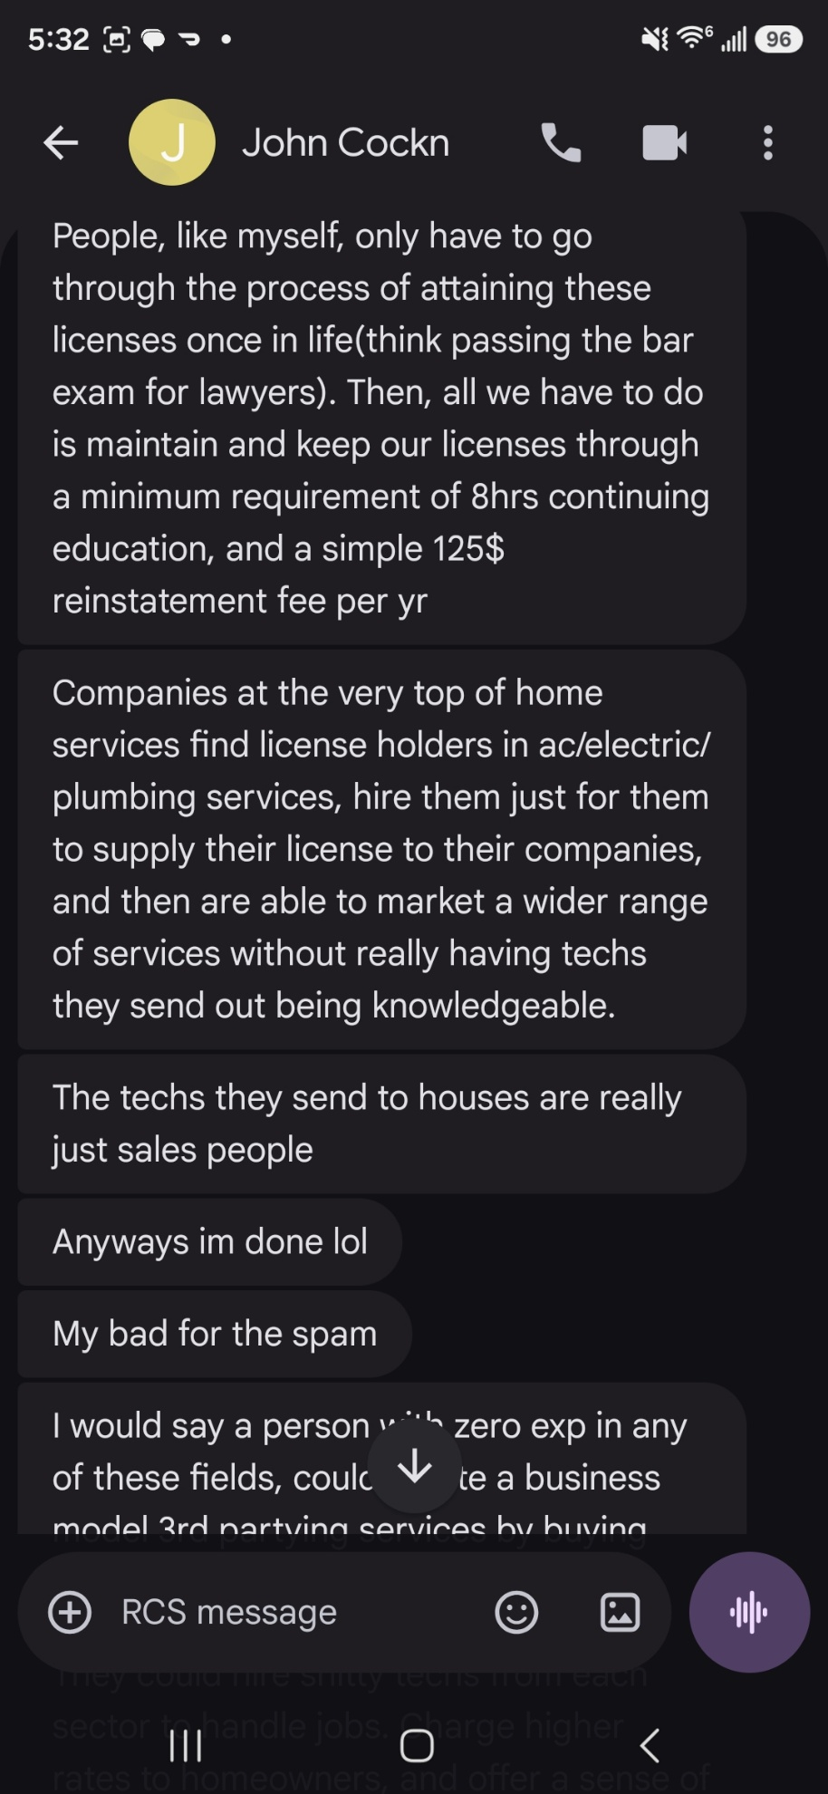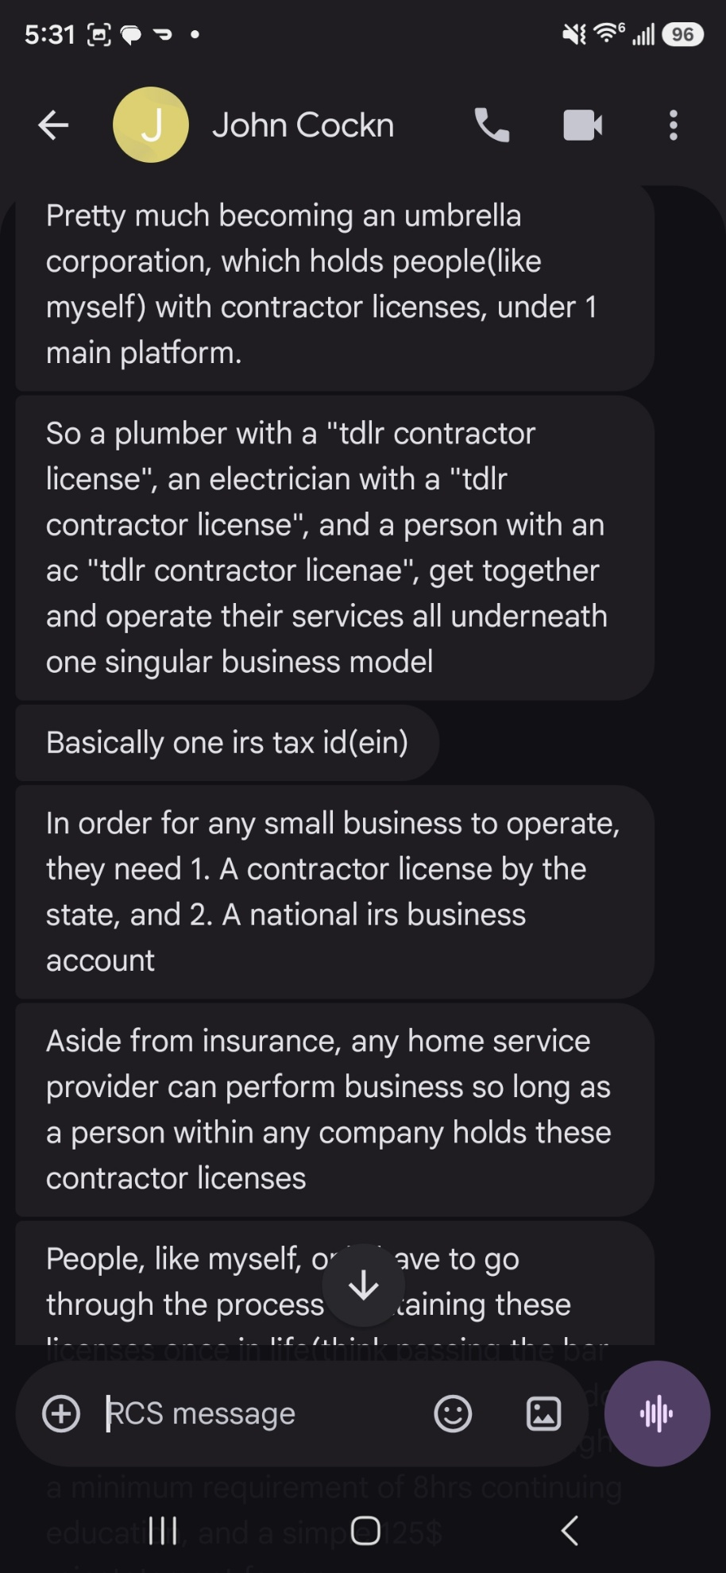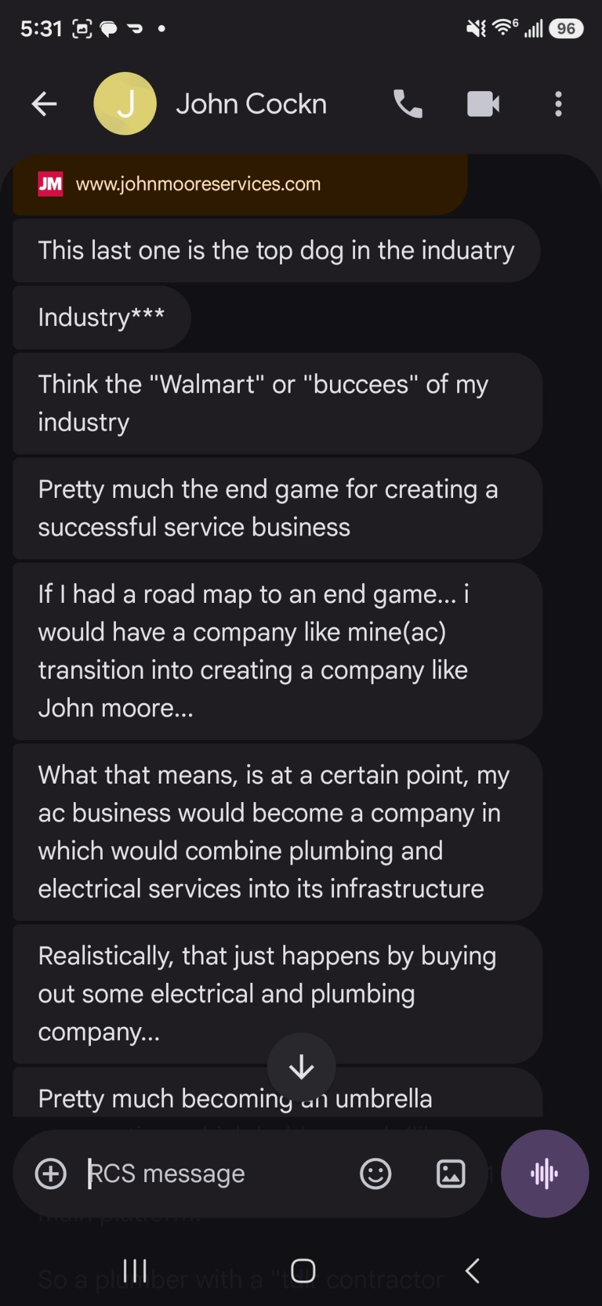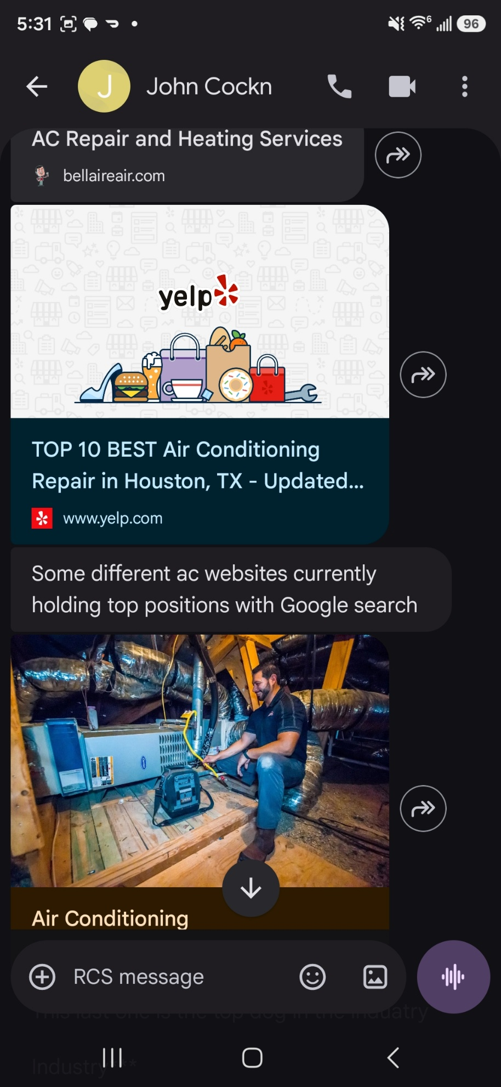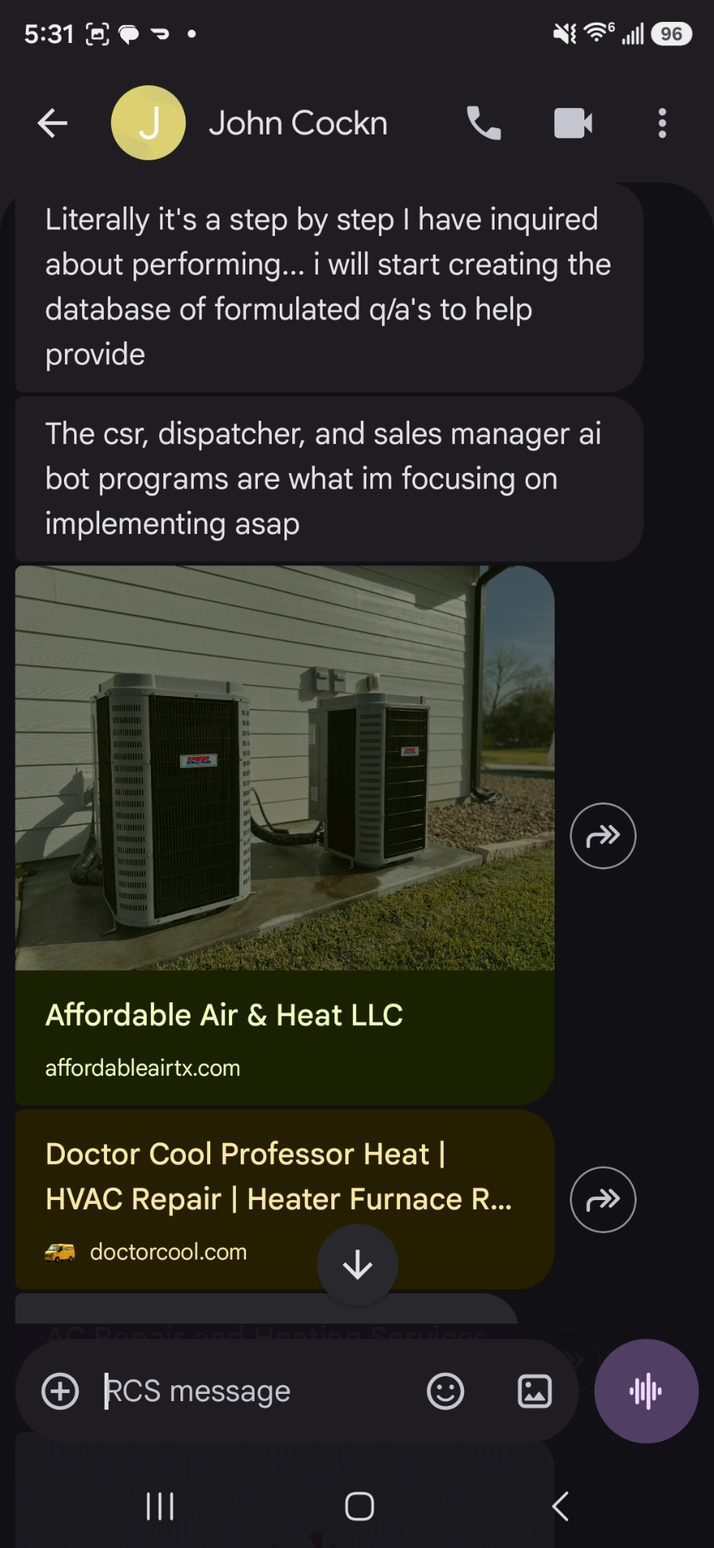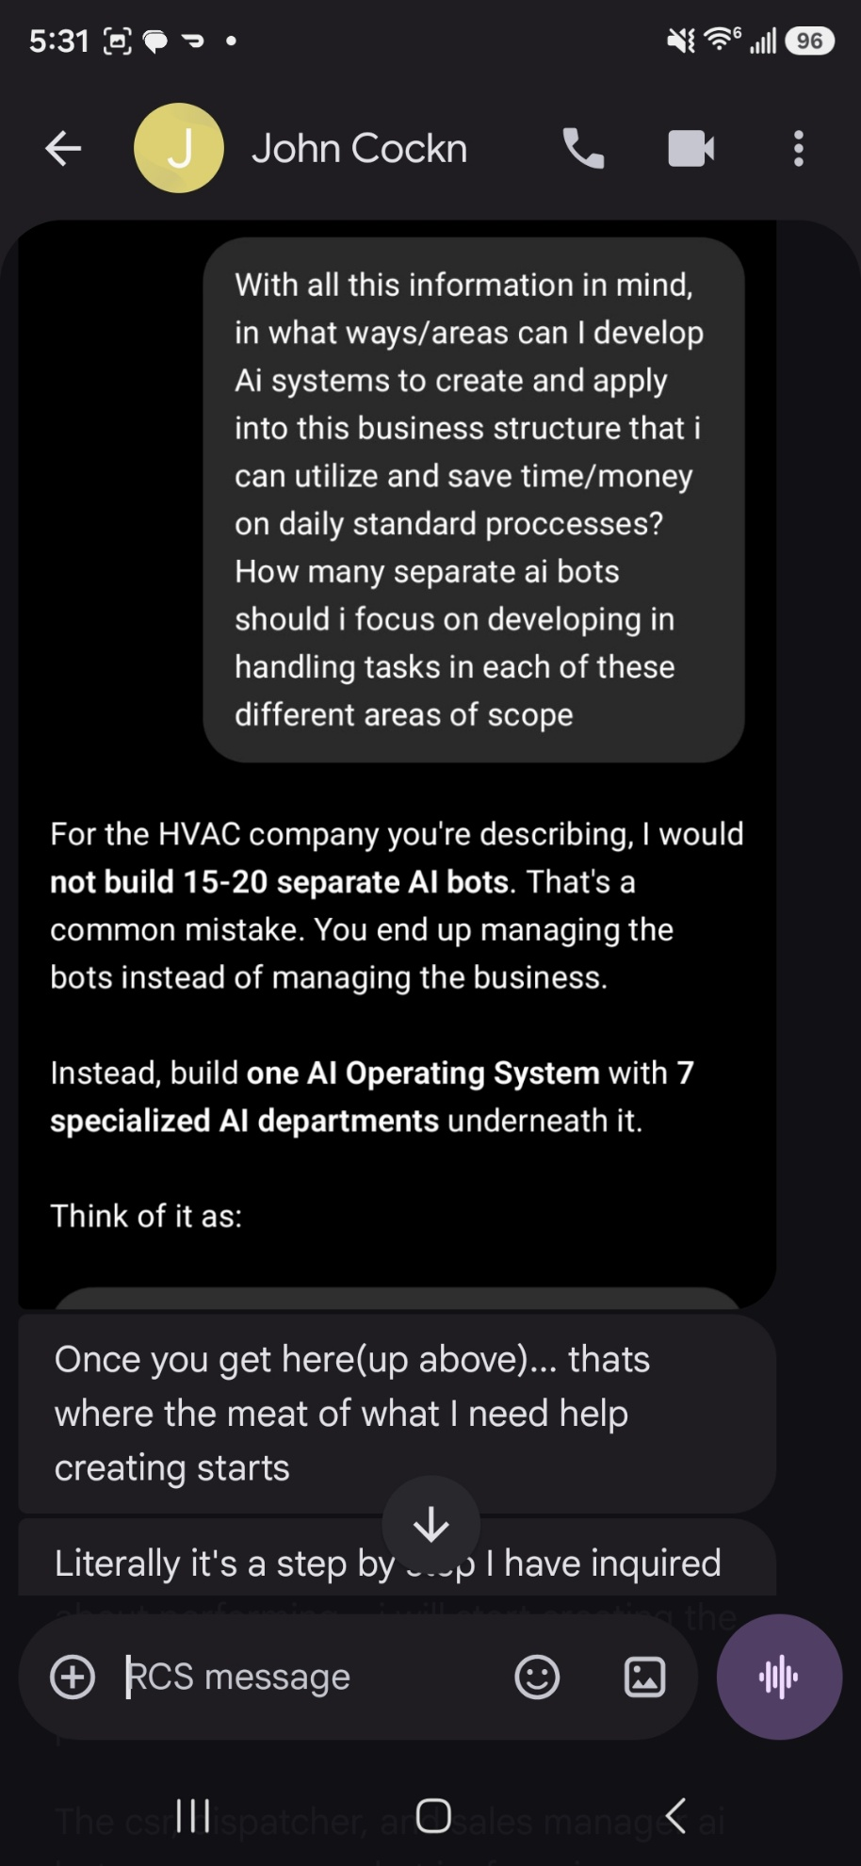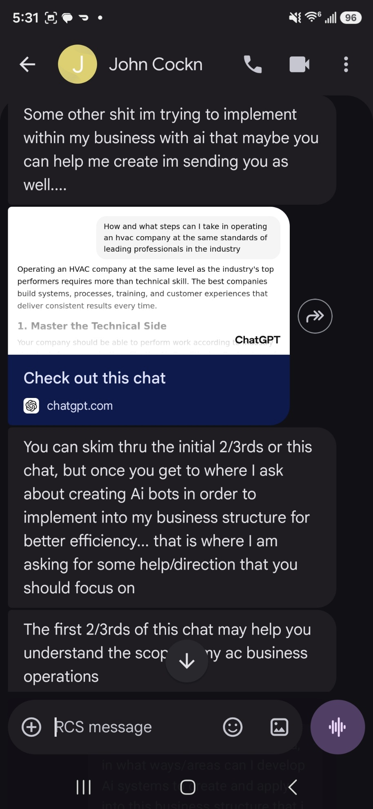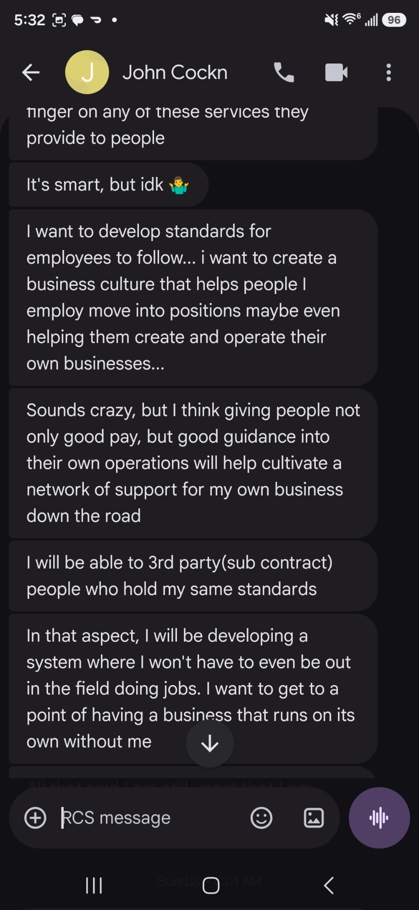
References:

https://chatgpt.com/share/6a2e4081-a4d4-83ea-a78c-c3f2ec3eb4b8

https://affordableairtx.com/?gad_source=1&gad_campaignid=23591259066&gbraid=0AAAAA-f-Ep_f3nyx6lRPq0ih7yvE8AZdC&gclid=Cj0KCQjw_7PRBhDcARIsAMjV7jlLbA7sblFbKbMjJitPByVK-VQvxj3XohOd-yeTd6Gg94lrKdaQGmEaAgocEALw_wcB

https://doctorcool.com/

https://bellaireair.com/

https://m.yelp.com/search?find_desc=Air+Conditioning+Repair&find_loc=Houston%2C+TX

https://www.johnmooreservices.com/air-conditioning/

